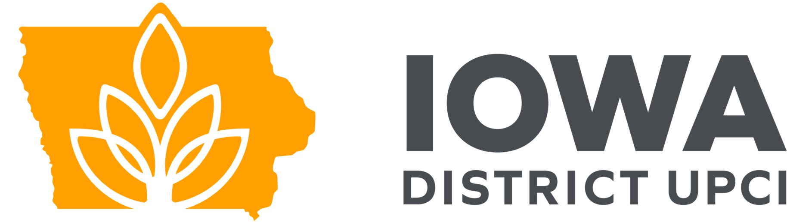

As a minister of the Iowa District you are required to give and financially support the district.

If you are a pastor
According to Article IV Section 7 of the Iowa Minsters guide.
- Each pastor is to send 50% of their tithes (secular and ministerial) to the District Secretary-Treasurer. Make all checks payable to the IOWA DISTRICT.

Example: If you receive $15,000 a year from a secular job, and $5000 a year from the church, your total yearly income would be $20,000. You would send 5% - or $1,000.00 for that year to the Iowa District. The Iowa District will use this example as a minimum expectation.

An exception is made for pastors on NAM status who will be required to contribute $15/month during their appointment.

- All licensed ministers, other than pastors and full-time evangelists, are to contribute $15.00 a month to the Iowa District with the suggestion that the $15.00 be taken from the tithe of the licensed minister in the church.

- All full-time evangelists licensed with the Iowa District are to send in 100% of their tithe to the Iowa District. On September 10th, an amount equal to 75% of the tithes are to be returned to the evangelist.

- All accounts must be current by the end of each calendar year. Postmarked mail by December 31 will be recorded within that calendar year.

  - A 31 day “grace window” will be afforded until January 31 to fulfill your account requirements.

  - Anyone who still has a delinquent account on January 31 for the previous calendar year, will be placed on a “to be dropped” list on February 1. Individuals placed on that list will be contacted.

  - If the individual pays their district dues in full by February 15, their name will be removed from the drop list. Otherwise, he or she will be dropped on February 15 with the Iowa District and with the UPCI. In the event that the 15th falls on a Saturday or Sunday, the effective drop date will be the following Monday.

  - Ministerial tithes and dues should be mailed to the current District office address.

  - Ministerial tithes and dues may also be paid online at www.Iowadistrictupci.com.

